EVALUACIÓN
DE
MATEMÁTICAS
“TICKETS DE SALIDA”

TICKET 1
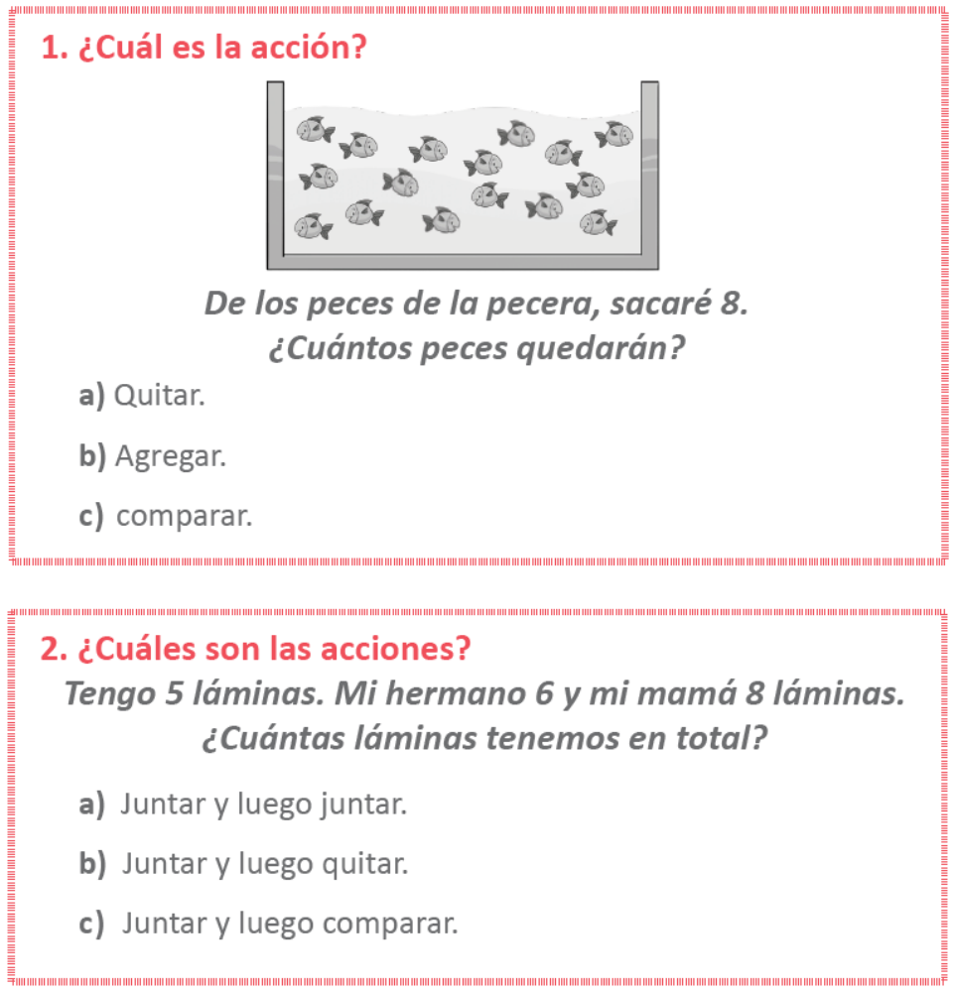

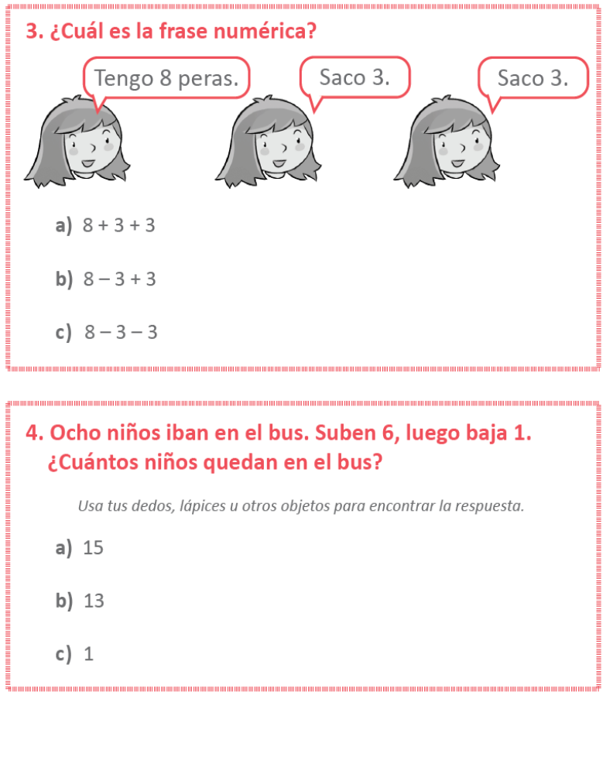
TICKET 2
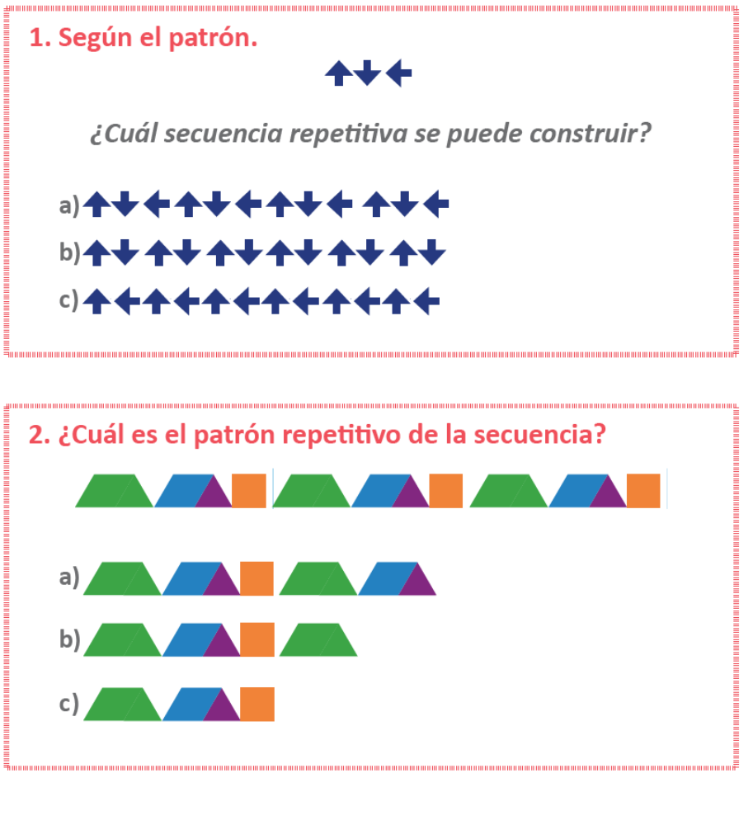
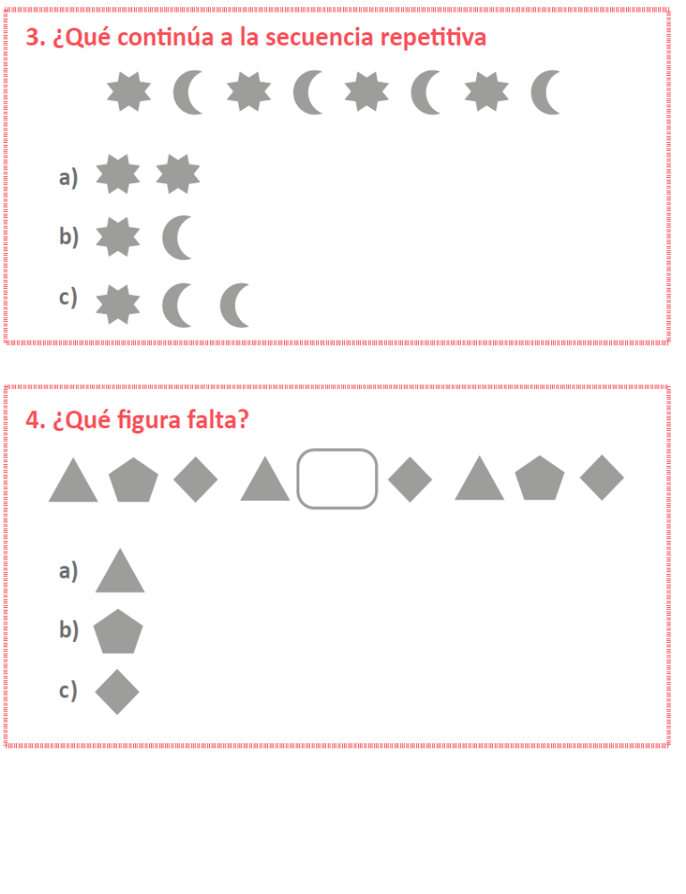
TICKET 3
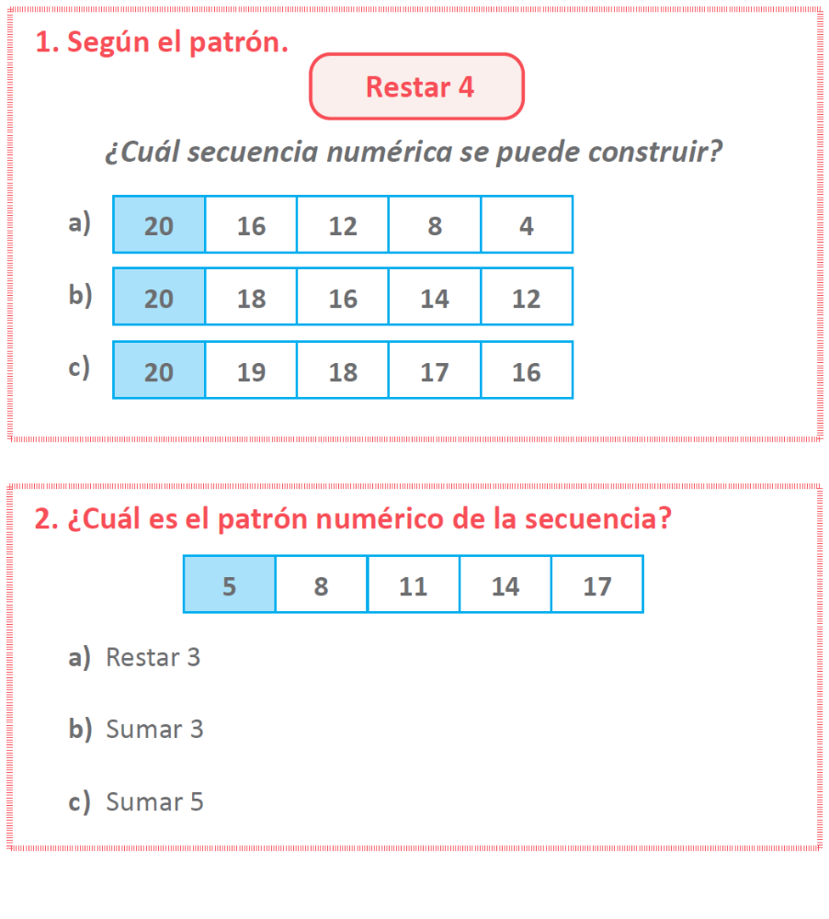
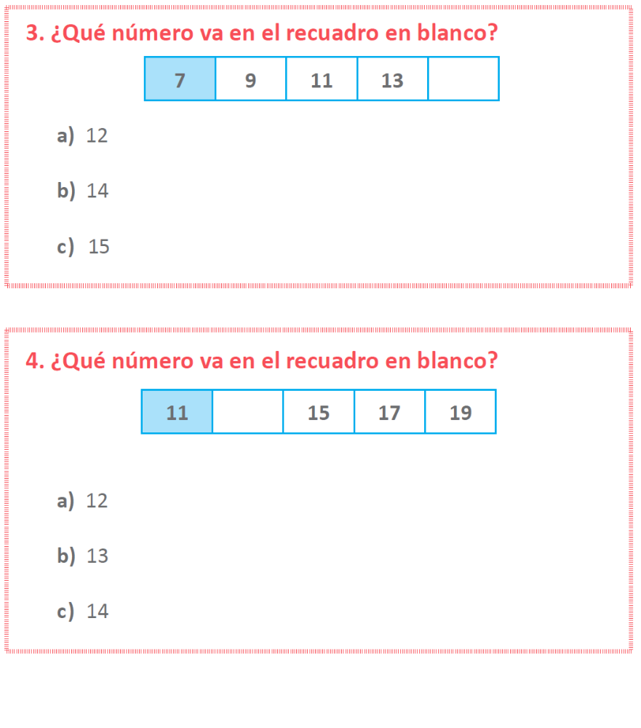

TICKET 4
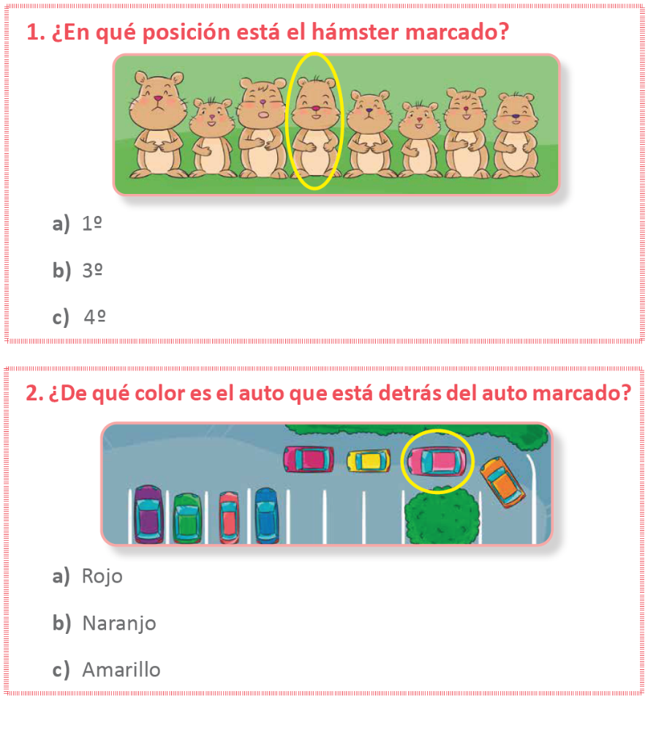
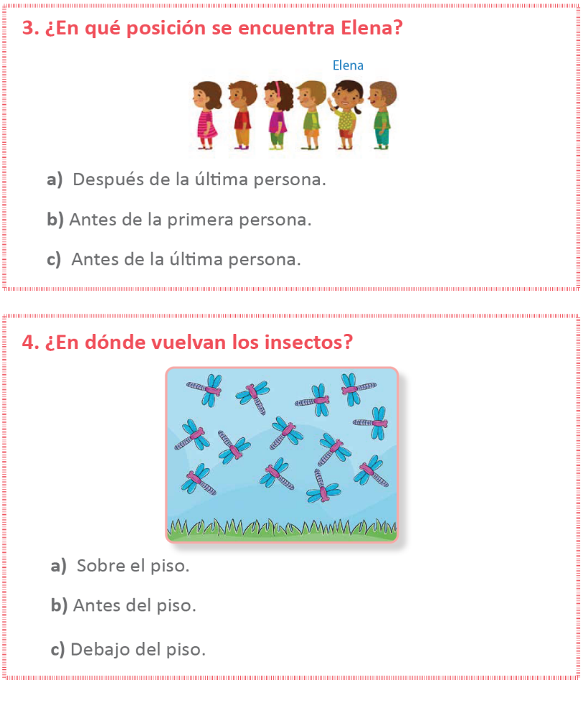
TICKET 5
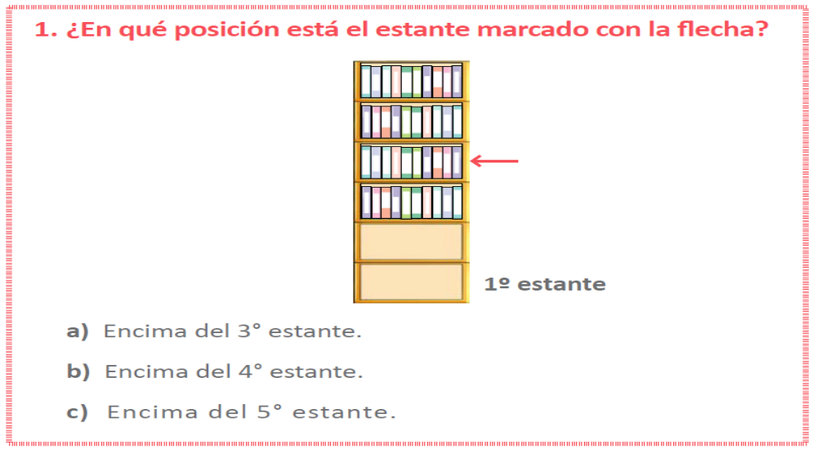
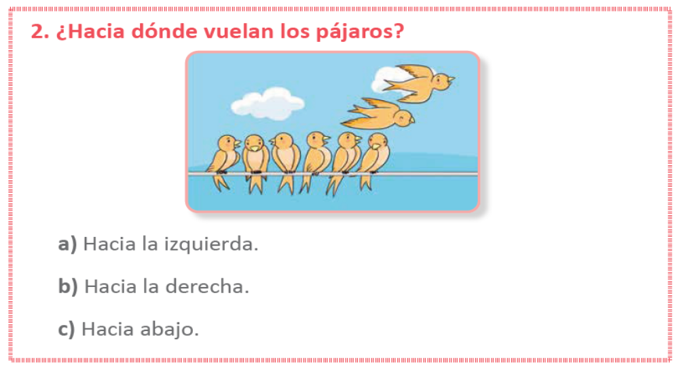
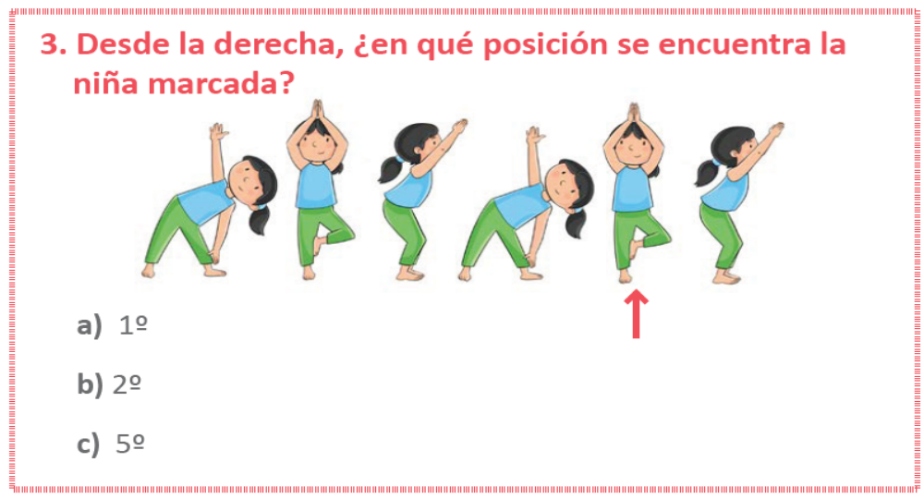
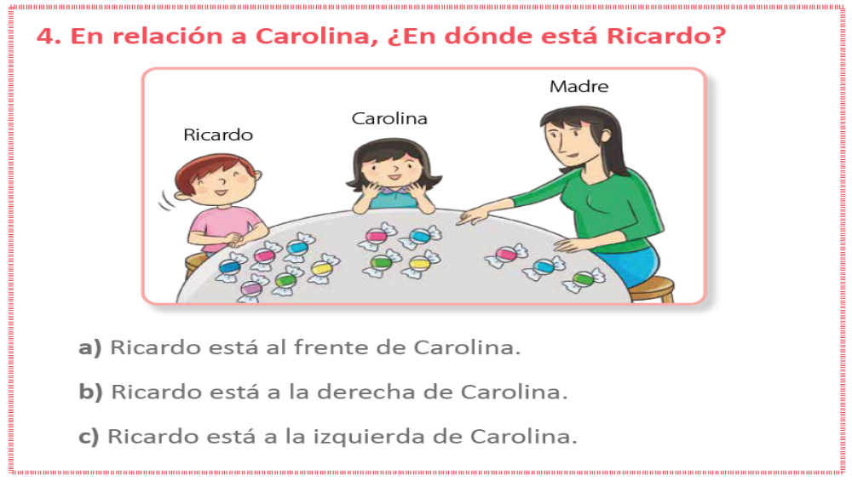

TICKET 6
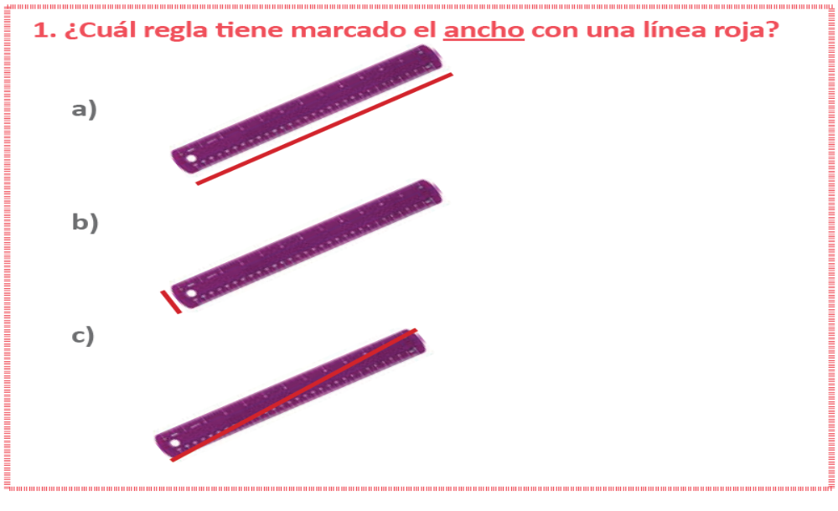
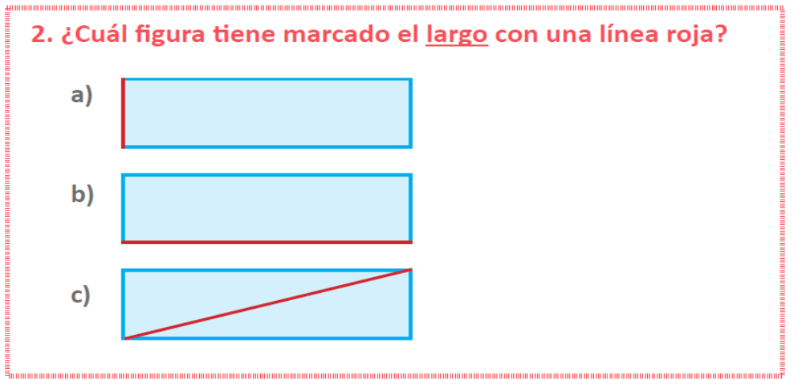
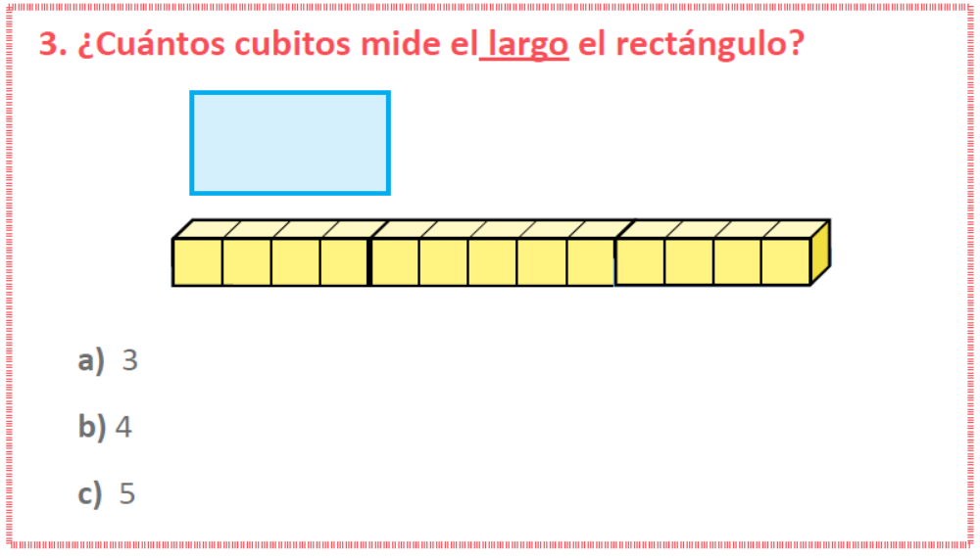
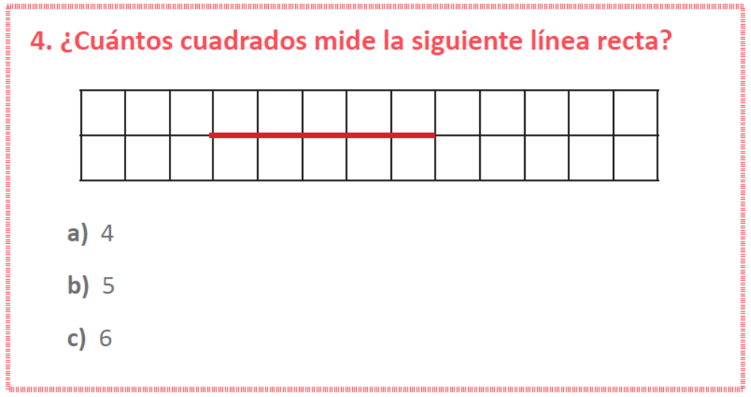

TICKET 7
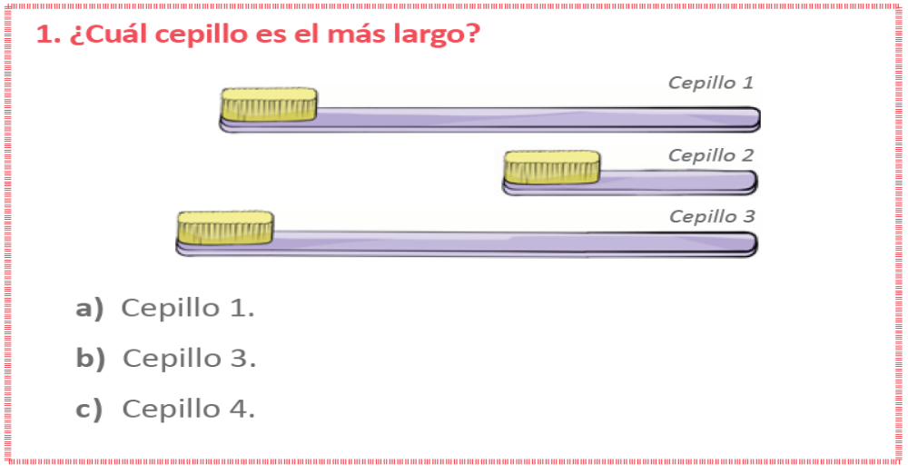
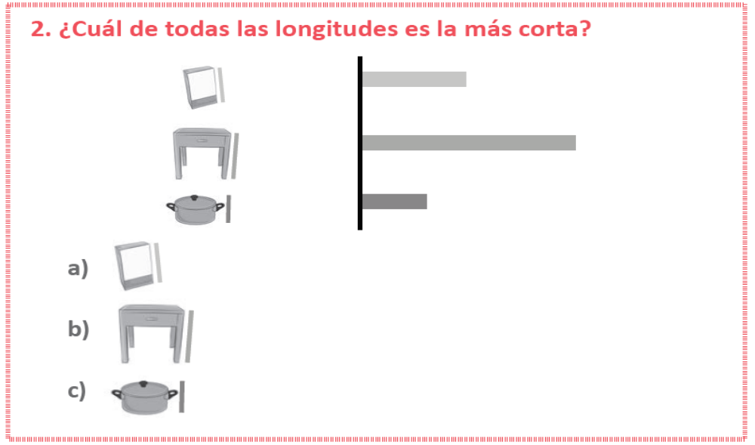
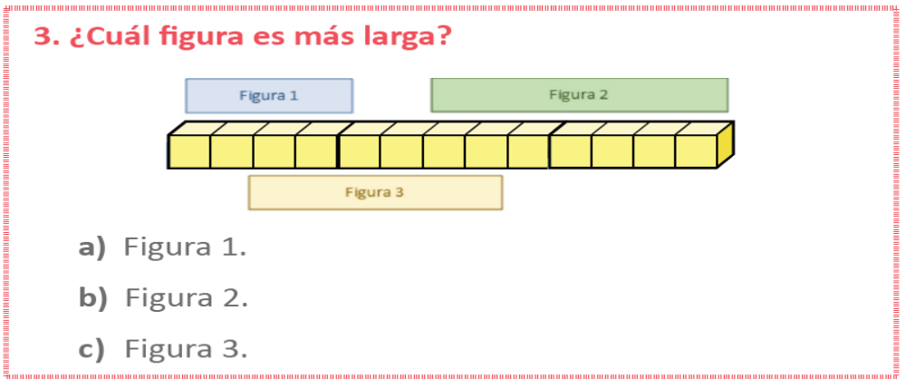
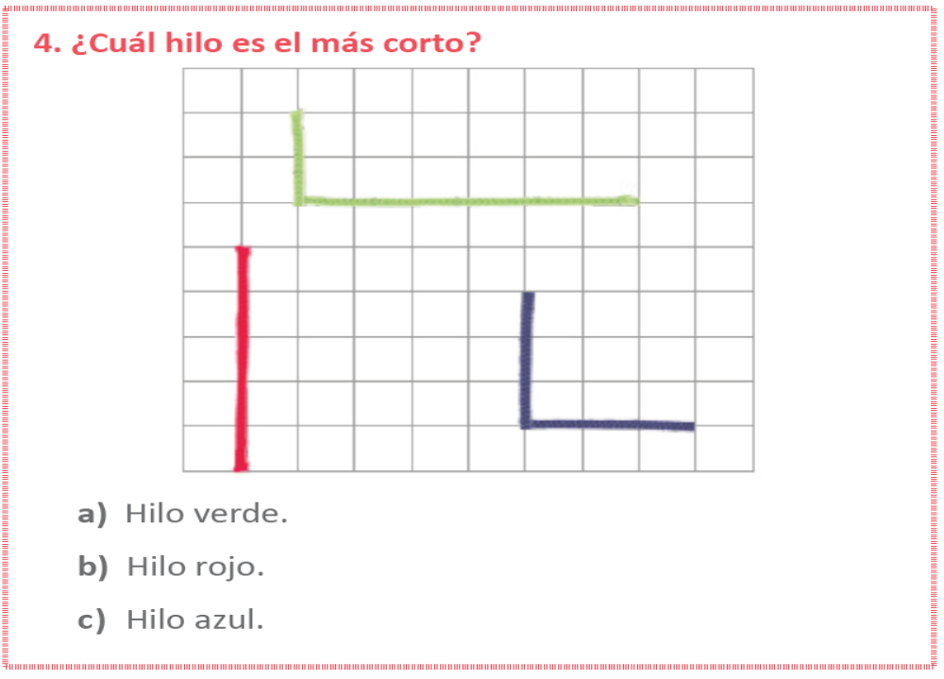

TICKET 8
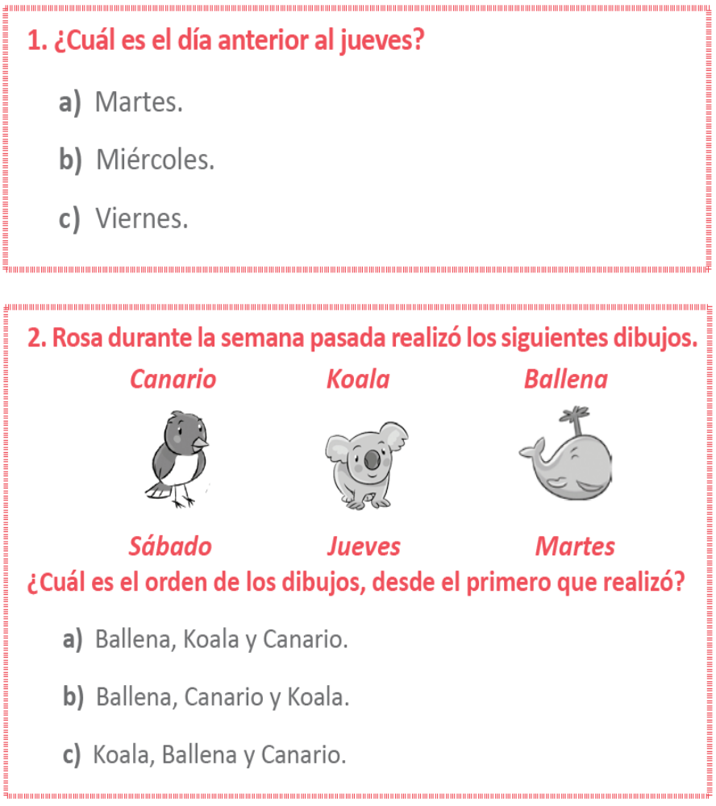
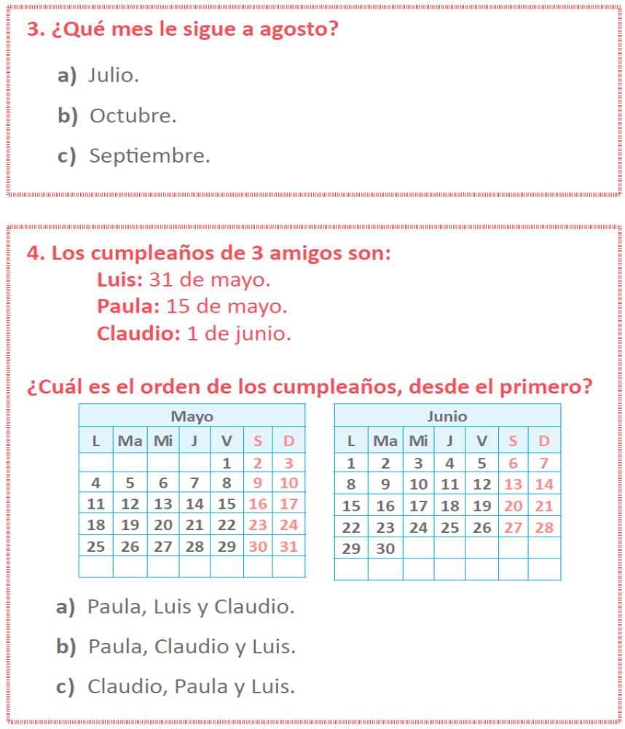

TICKET 9
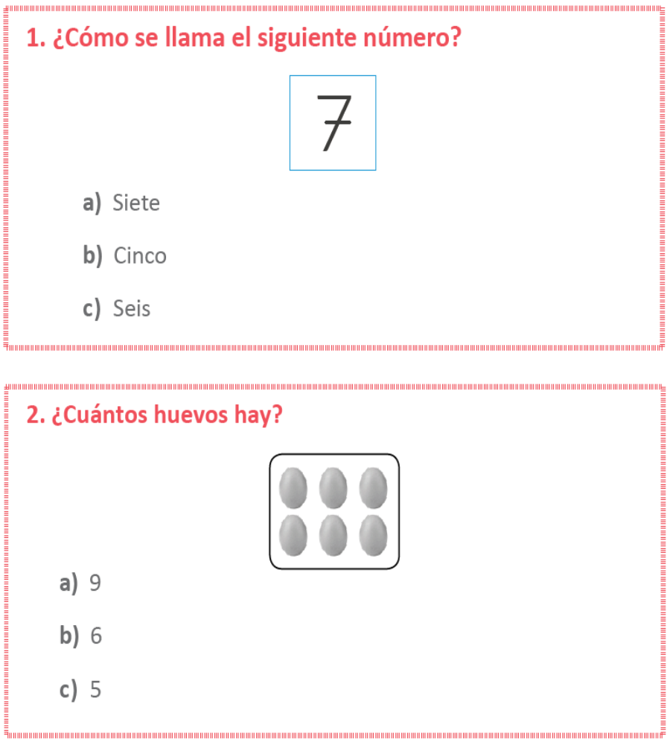

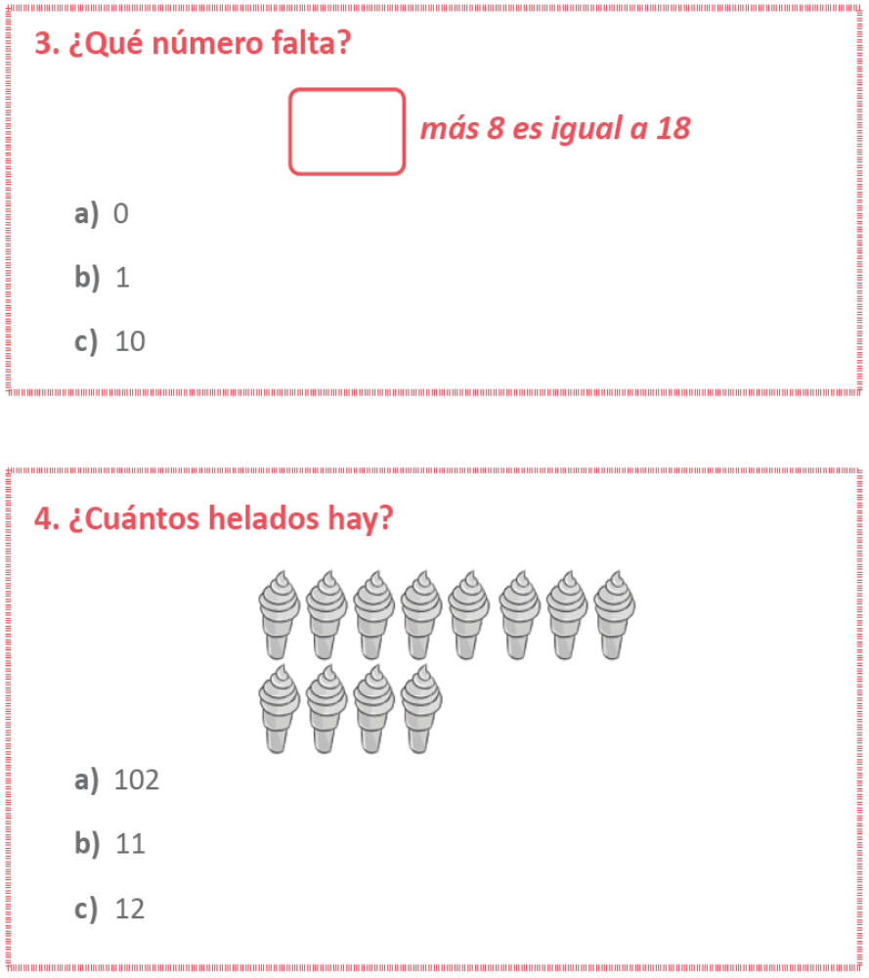

HOJA DE RESPUESTAS
PINTE BIEN LA CASILLA DE LA ALTERNATIVA CORRECTA
TICKET | PREGUNTA | RESPUESTA
1 | 1 | A | B | C
1 | 2 | A | B | C
1 | 3 | A | B | C
1 | 4 | A | B | C
2 | 1 | A | B | C
2 | 2 | A | B | C
2 | 3 | A | B | C
2 | 4 | A | B | C
3 | 1 | A | B | C
3 | 2 | A | B | C
3 | 3 | A | B | C
3 | 4 | A | B | C
4 | 1 | A | B | C
4 | 2 | A | B | C
4 | 3 | A | B | C
4 | 4 | A | B | C
5 | 1 | A | B | C
5 | 2 | A | B | C
5 | 3 | A | B | C
5 | 4 | A | B | C
6 | 1 | A | B | C
6 | 2 | A | B | C
6 | 3 | A | B | C
6 | 4 | A | B | C
7 | 1 | A | B | C
7 | 2 | A | B | C
7 | 3 | A | B | C
7 | 4 | A | B | C
8 | 1 | A | B | C
8 | 2 | A | B | C
8 | 3 | A | B | C
8 | 4 | A | B | C
9 | 1 | A | B | C
9 | 2 | A | B | C
9 | 3 | A | B | C
9 | 4 | A | B | C

